01. Home
Customer Web App Wireframe | Korean Version
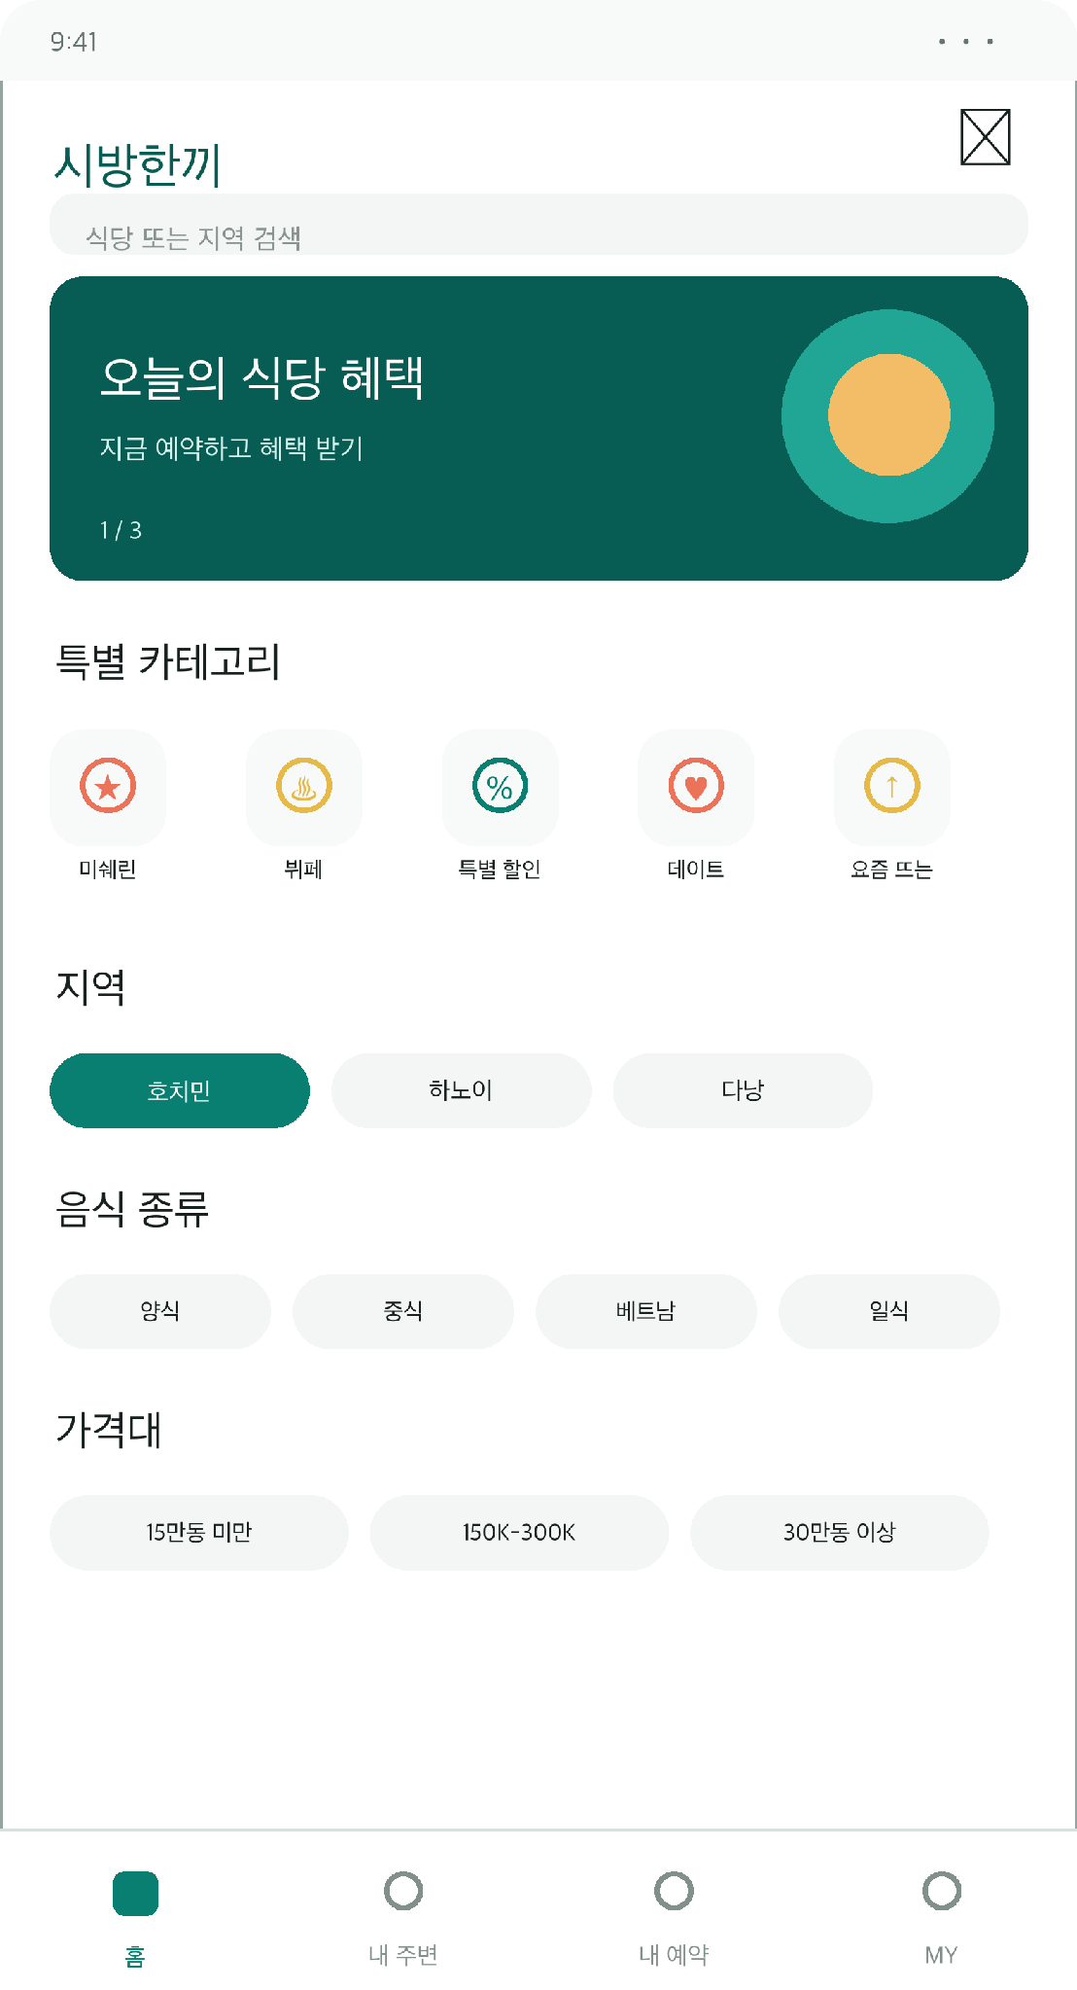

02. Restaurant List
Customer Web App Wireframe | Korean Version
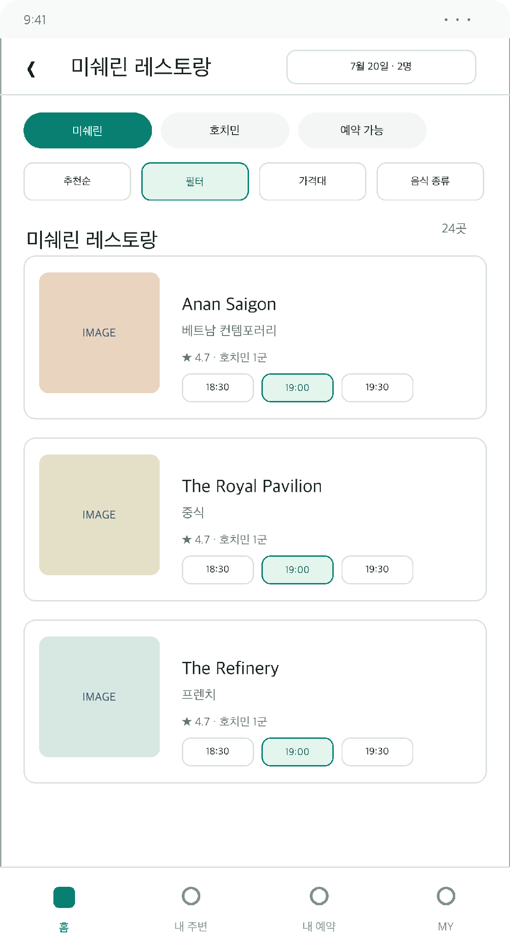

03. Detailed Filters
Customer Web App Wireframe | Korean Version
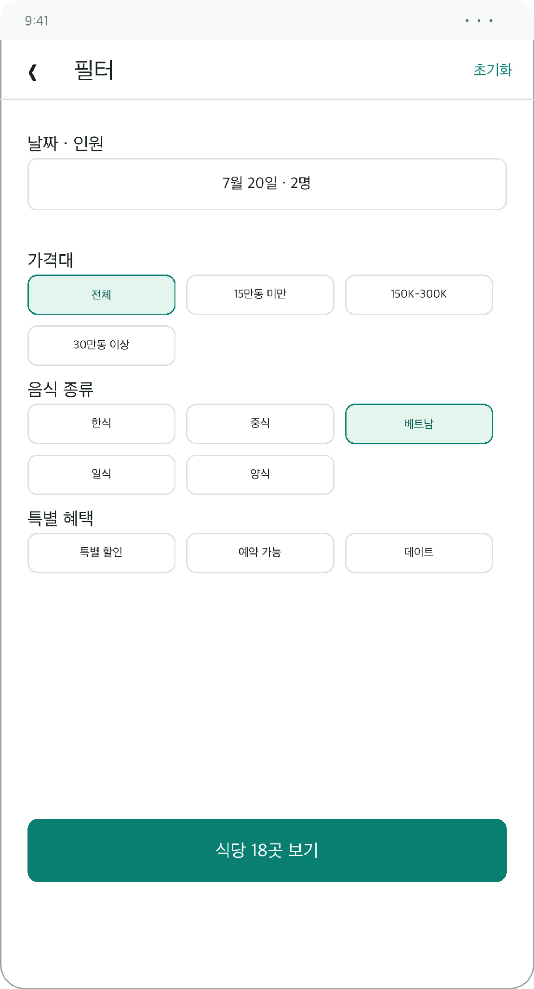

04. Restaurant Details
Customer Web App Wireframe | Korean Version
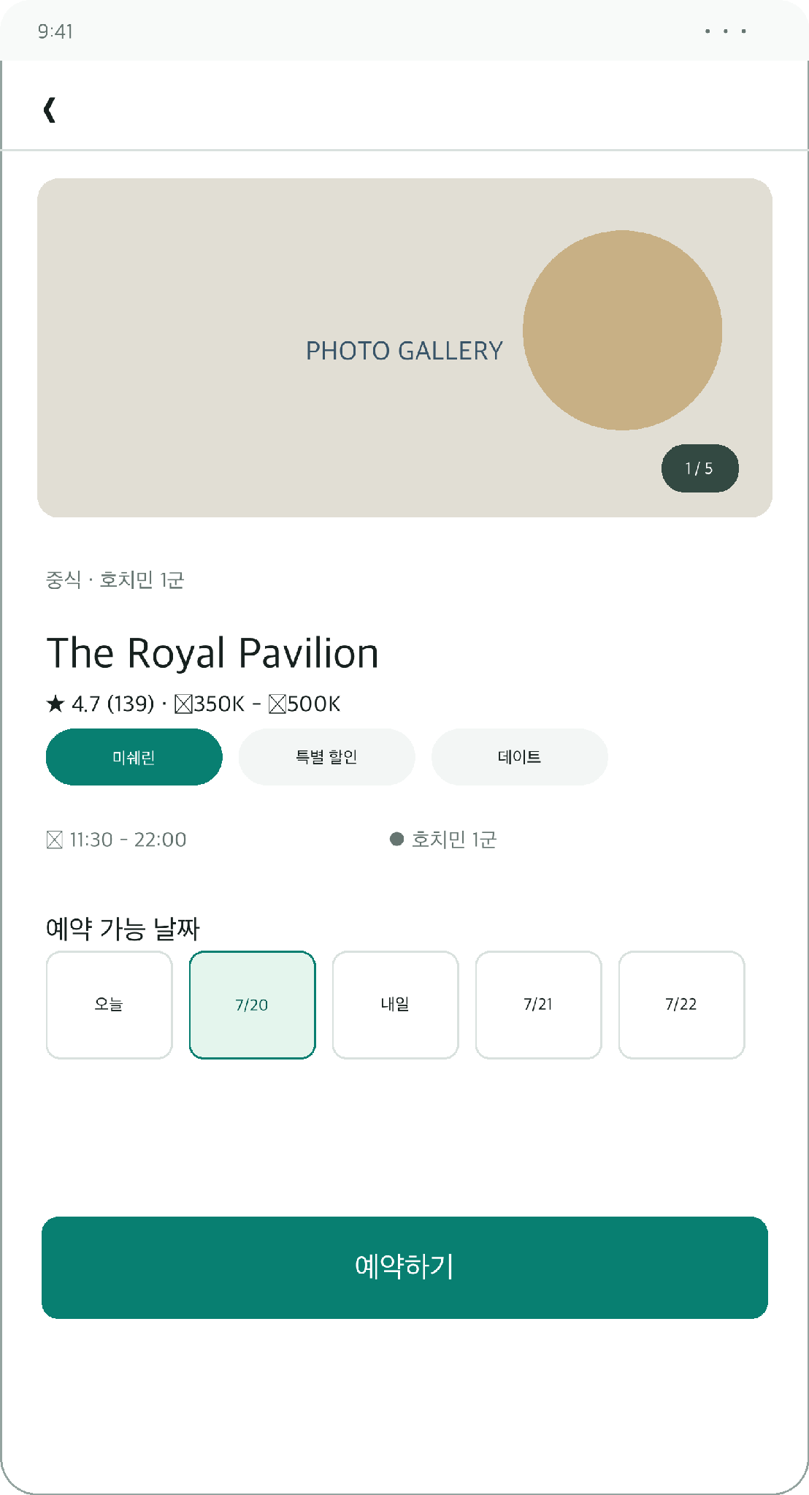

05. Reservation
Customer Web App Wireframe | Korean Version
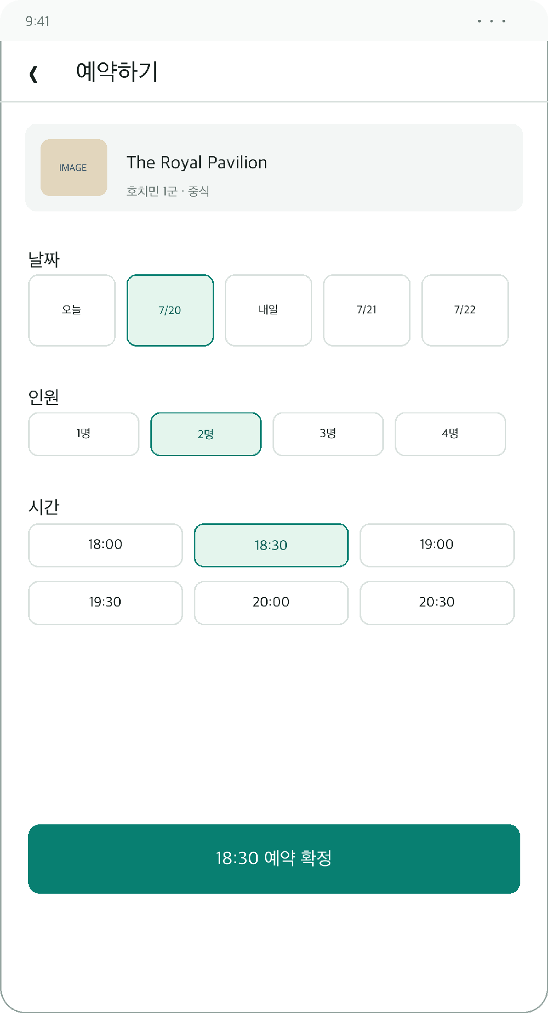

06. My Reservations
Customer Web App Wireframe | Korean Version
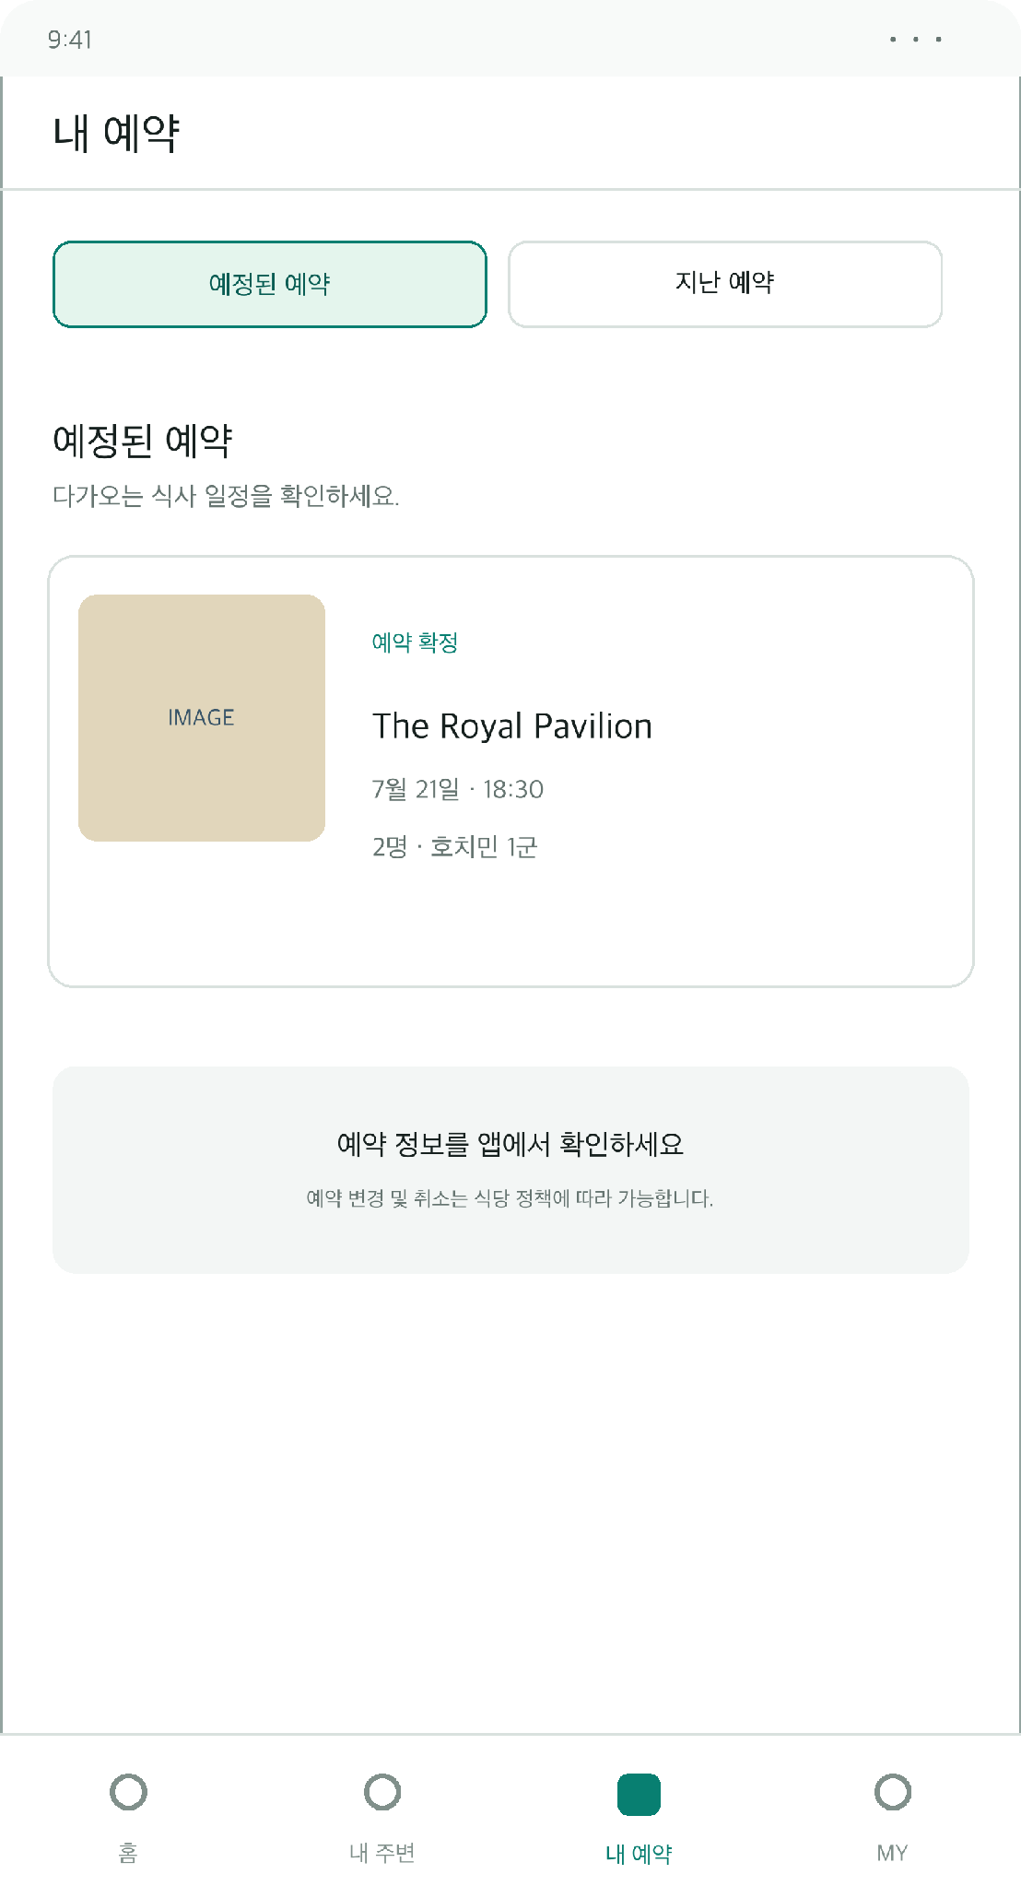

01. Home
Customer Web App Wireframe | English Version
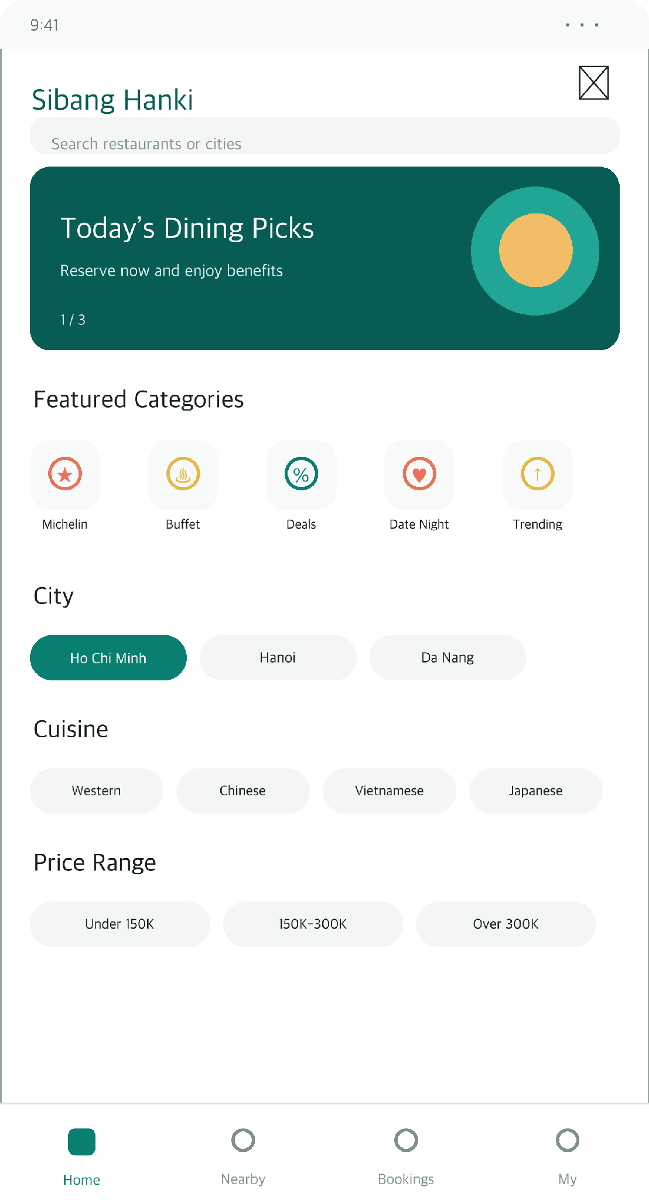

02. Restaurant List
Customer Web App Wireframe | English Version
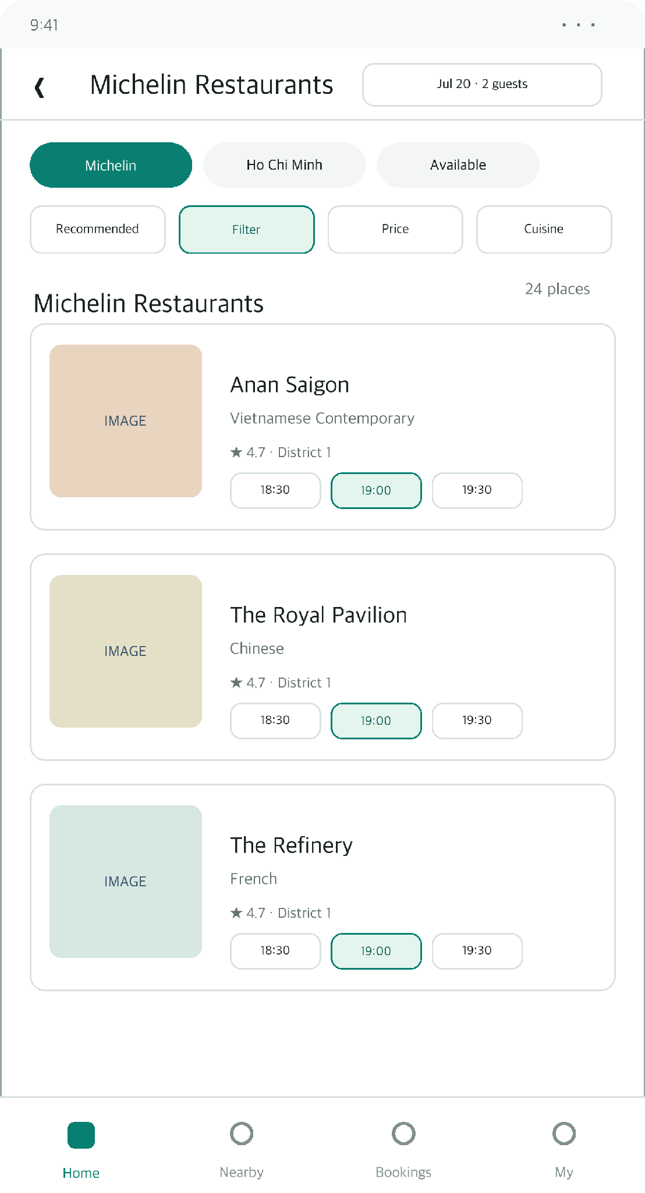

03. Detailed Filters
Customer Web App Wireframe | English Version
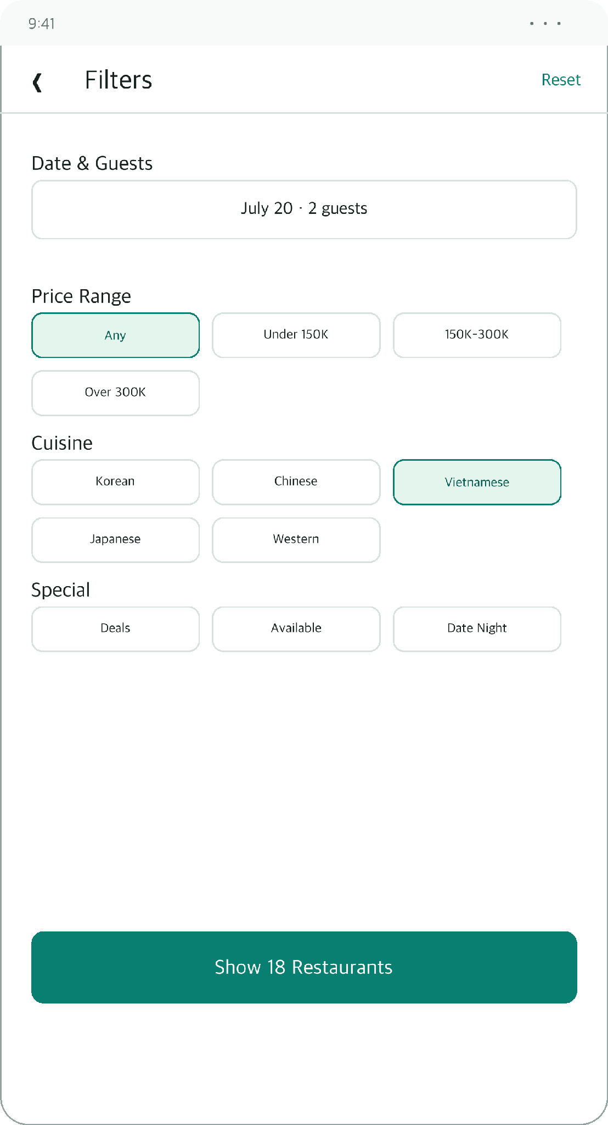

04. Restaurant Details
Customer Web App Wireframe | English Version
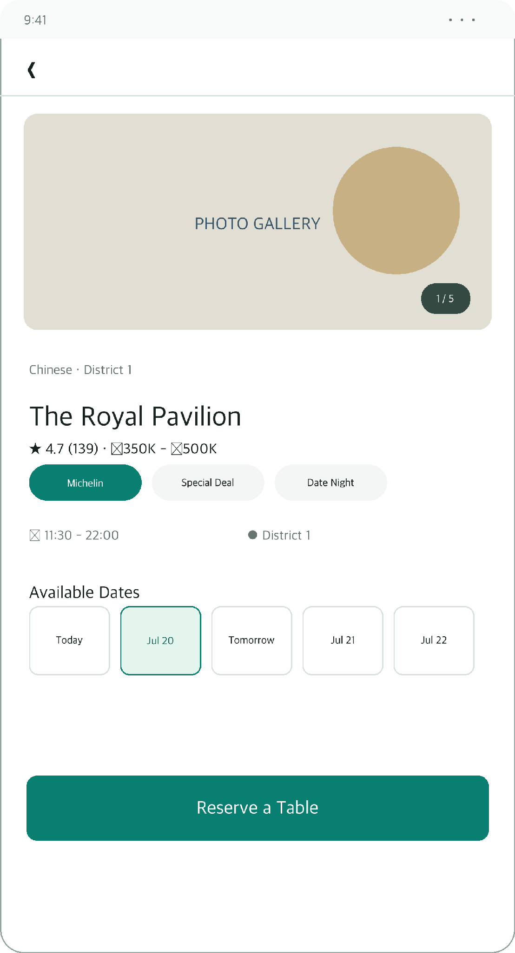

05. Reservation
Customer Web App Wireframe | English Version
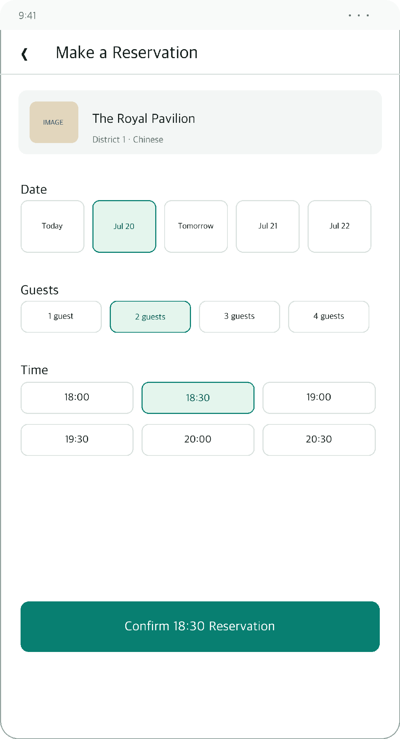

06. My Reservations
Customer Web App Wireframe | English Version
